Geometry: Unit 10, Lesson 2
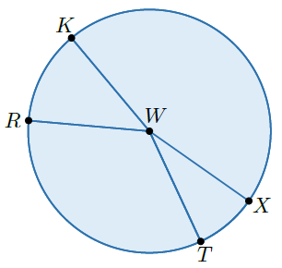
- Circle $W$ is shown with point $K$, $R$, $T$, and $X$ on the circle. What central angle has radii that intersect the circle to show $\hat{TR}$?

$$∠RWT$$

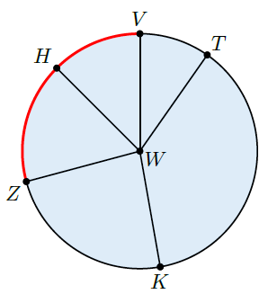
- Circle $W$ is shown with points $V$, $H$, $Z$, $K$, and $T$ on the circle. An arc on circle $W$ between points $Z$ and $V$. The intercepted arc of which angles is given?

$$∠ZWV$$

- What is a piece of information that is used when determining the circumference of a circle?

The radius

